

Internal Audit – KUTC

Process Understanding Document

Prepared by | Waseem alwahedy / Ahsan Niazi
Date | Feb 2023

Center Vision
To be an open research platform in the UAE.
Center Mission
Support and upgrade UAE research infrastructure Facilitate collaborative R&D between the UAE and Korea; Develop a scientific exchange hub in the UAE; Build joint research laboratories

Center Function
- Facilitate Collaborative R&D.
- Joint Research Laboratories.
- UAE Research Infrastructure Support.
- Scientific Exchange Hub.

Strategic Goals and Objectives
KUTC Plan for developing collaboration projects under KUTC and strategic directions was developed in July 2020 which highlighted the following:
- Identifying more stakeholders from UAE side (government and industry sectors) to secure the co-funding in order to extend research focused areas into energy, catalysts, health, oil & gas, semiconductors, etc.
- Buildingup advisory board by inviting top management from potential stakeholders nationally.
- Acquiringphysical space within campus for improving visibility of the center and effective interaction with other research centers
- AcknowledgingKUTC on the publications with KUTC staff’s engagement

Alignment KU Research 2017 Strategy:
- “Horizontals” focused on cross-cutting critical enablers in which KU has competitive advantage
  - Advanced Materials & Manufacturing
Alignment KU Research 2022 Strategy:
- As per the KU Research Strategy 2022, an action plan was to review of center and decision on center renewal by December 2022.

Center Reseach Themes
- Advanced Materials – Energy
- Advanced Materials – Oil & Gas
- Advanced Materials – Catalyst
- Advanced Materials – Biomedical
- Semiconductor Devices / Characterization
Agreements and Memorandum of Understanding
Memomorandum of Understanding (MoU)
- An MoU was signed Between Korea Basic Science Institute (KBSI) and Khalifa University (KU) on 01 November 2018 which required Establishment of a Korea-UAE Joint R&D Technical Center.

- The MoU required KU and KBSI to establish definitive agreement relating to the Technical Center prior to 31 March 2019.

- The MoU expires in November 2023. However, it has an extension clause and that it can be extended by mutual written agreement at least three months prior the expiration.

- MoU highlighted the following:

  - KUTC will house KBSI technical staff who will provide expertise for the utilization of research laboratory equipment which will be under management of the KU Research Laboratories Department.

  - Separate written agreements will be established for Collaborative Research Projects which will also identify management of intellectual property rights. The expenses shall be agreed in separate agreements before commencement of any activity.

KUTC Agreement
- The Agreement for establishment of KUTC was signed on 26 November 2019 which was effective from 30 June 2019 (for 5 years).

- Following are key highlights from the Agreement:

  - A Steering Committee will be established with 2 representatives from each party. Steering Committee will meet on quarterly basis.

  - KUTC will have a KUTC Director and KUTC Manager.

  - KUTC will aim to supply supply efficient and reliable research facilities and equipment required for joint R&D researchers of KBSI and KU.

  - Operate laboratory in the UAE for KBSI and KU researchers to participate in joint research.

  - KU will provide office and laboratory space for KUTC together with administrative support.

  - KU will make available the pre-existing facilities and equipment for the KUTC, together with suitable office space. Subject to the approval of the Steering Committee, KU may make available different I additional

  - laboratory and/or office space and/or equipment (as specified in Appendix 2) for the KUTC, under terms and conditions to be contained

  - in a separate legal agreement. KBSI will be responsible for the costs associated with the installation and/or operation of any such laboratory and/or office space

  - No variations or amendment of this agreement will be effective unless it is made in writing.

Organisation Chart
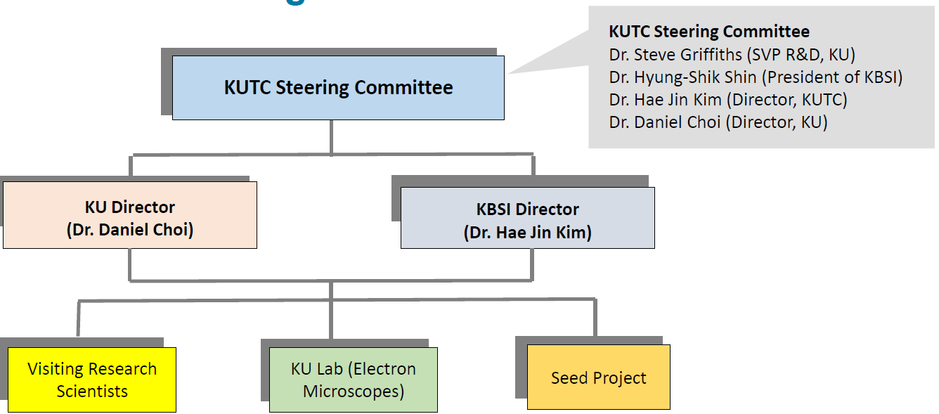
Budget vs Actuals
A separate budget code is not applicable for the center. The budgeting is performed and accounts are created for Research Projects initiated under KUTC. The agreement for the establishment KUTC has no budget commitments from either parties.
Key Performance Indicators
- No Documented Key Performance Indicators are available for the Center.
Research Projects
- 1 Seed – Cofunded Research Project was initiated and completed under KUTC between 2019 and 2022.
- The funding parties to the Research Project were Khalifa University and KUTC.
- No separate collaborative Research Agreement for the research project is available.
- USD 100K per year per partner to research agreement was agreed.
- Budget details of the research project are as follows:
 | Research Progress Report | Project Fund Report | Variance | Project Fund Report Actual | Utlzn | Underutilisation
Dates of Project - Start | 01-Jul-19
Dates of Project - End | 30-Jun-22
Budget 2019 | 31,750 | 31,750 | - | - | 0% | 100%
Budget 2020 | 367,250 | 367,250 | - | 246,492 | 67% | 33%
Budget 2021 | 367,250 | 347,250 | 20,000 | 287,828 | 83% | 17%
Budget 2022 | 335,500 | 335,500 | - | 215,940 | 64% | 36%
 | 1,101,750 | 1,081,750 | 20,000 | 750,261 | 69% | 31%

Reporting
3 Progress reports have been issued with respect to Co-Funded Research Project 8474000259 – “Development of solid electrolytes for harsh environment batteries”.

